Lab 13 Controlled Experiments: Lab Assignment 2:
Name: Arsalan Saleem SP23-BSE-070 Section:BSE 7A

Objective:
The objective of this lab is to give hands of experience to the students on planning, executing and then analyzing the results of a controlled experiment.

Activity Outcomes:
The activities provide hands - on practice with the following topics
- Designing a controlled experiment
- Executing an experiment.
- Performing a t-test on the results.

1) Useful Concepts
Executing Controlled Experiments: You start by stating a clear, testable hypothesis. By testable, we mean that the hypothesis must be quantifiable and measurable. Here’s an example of a hypothesis that we might want to test that the Macintosh menu bar, which is anchored to the top of the screen, is faster to access than the Windows menu bar, which is separated from the top of the screen by a window title bar.
You then choose your independent variables - the variables you’re going to manipulate in order to test the hypothesis. In our example, the independent variable is the kind of interface: Mac menubar or Windows menubar. In fact, we can make it very specific: the independent variable is the y-position of the menubar (either y = 0 or y = 16, or whatever the height of the title bar is). Other independent variables may also be useful. For example, you may want to test your hypothesis on different user classes (novices and experts, or Windows users and Mac users). You may also want to test it on certain kinds of tasks. For example, in one kind of task, the menus might have an alphabetized list of names; in another, they might have functionally-grouped commands.
You also have to choose the dependent variables, the variables you’ll actually measure in the experiment to test the hypothesis. Typical dependent variables in user testing are time, error rate, event count (for events other than errors - e.g., how many times the user used a particular command), and subjective satisfaction (usually measured by numerical ratings on a questionnaire).
Finally, you use statistical techniques to analyze how your changes in the independent variables affected the dependent variables, and whether those effects are significant (indicating a genuine cause-and-effect) or not (merely the result of chance or noise).

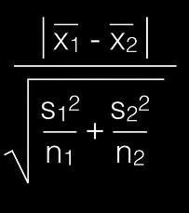
t-value

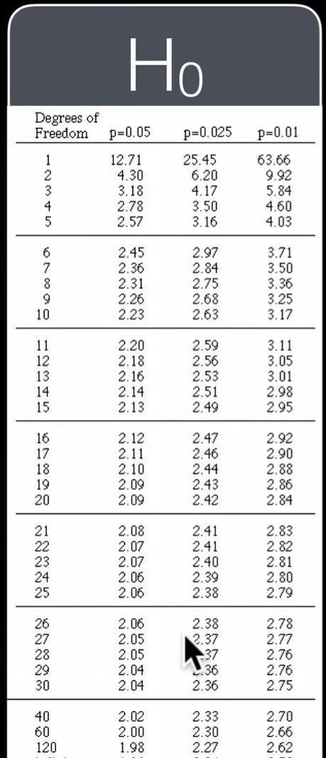

Solved Lab Activites: Activity 1
Designing a Controlled Experiment
We want to compare the typing speed of kindle and ipad keyboard
Hypothesis: “University students (population) type (task) faster (measurement) using iPad’s keyboard (feature) than using Kindle’s keyboard”
One tailed hypothesis
Null Hypothesis: “There is no difference in speed when university students type using kindle or ipad” IV: Type of keyboard
DV: time
Experimental Design: We would take 20 university students from different departments and then randomly assign them to one of the experimental conditions
Condition A: Type the given paragraph using ipad
Condition B: Type another paragrapgh of the same length using kindle.

Activity 2
Applying t-test
The following data was gathered after executing the above experiment
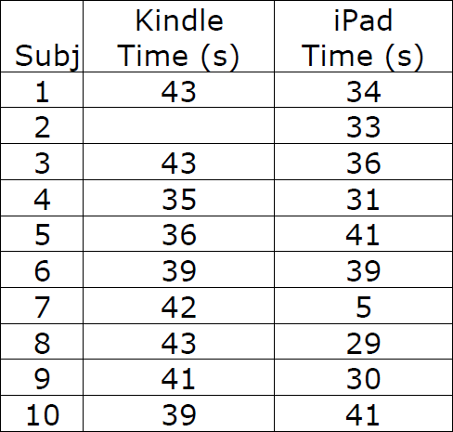

Now we will apply t-test on this data
First we calculate the t-value as given in the formula above.
 | Kindle | ipad
 | 43 | 34
 | 37 | 33
 | 43 | 36
 | 35 | 31
 | 36 | 41
 | 39 | 39
 | 42 | 37
 | 43 | 29
 | 41 | 30
 | 39 | 41
Mean | 39.8 | 35.1
Standard deviation | 3.047768 | 4.408325
Variance | 9.288889 | 19.43333
Count | 10 | 10

X1-x2 = |  | 1.360558
variance/count= |  | 0.928889
Adding= |  | 2.872222
Sqrt= |  | 1.694763
t-value= |  | 0.802801
df= | n1+n2-2
 | =18
critical value is 1.73

Our t-value is 0.8 which is less then critical value so we cannot reject null hypothesis
You can do all these calculations in excel

Graded Lab Tasks:
Lab Task 1
Design a controlled experiment to test whether its faster to upload assignment on CUOnline or Teams. I have created dummy assignments on both platforms for you so you can test it. You have to submit individually but must collaborate with your entire class to collect data.

Write the hypothesis, IV, DV, is it one tailed or two tailed. Also design the protocol and use t-test to accept or reject your hypothesis.

You can use the following table
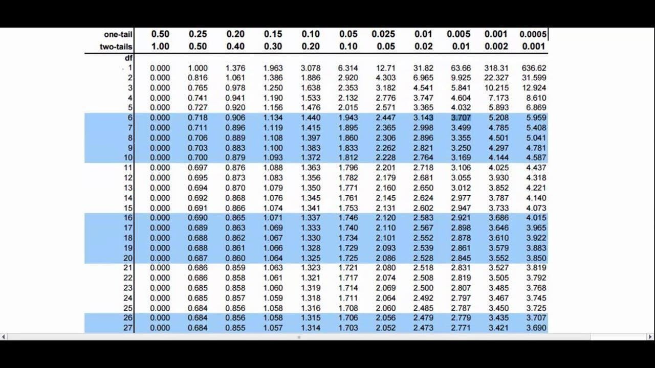

Solution

1. Hypothesis
Research Hypothesis (H₁): “University students (population) will upload (task) a dummy assignment faster (measurement) using Microsoft Teams (feature) than using CUOnline (feature).”
This is a one tailed hypothesis, because it predicts a specific direction of the effect (Teams will be faster than CUOnline) rather than simply predicting that the two platforms will differ.
Null Hypothesis (H₀): “There is no difference in the time it takes university students to upload an assignment on CUOnline versus Microsoft Teams.”

2. Variables
- Independent Variable (IV): Upload platform used CUOnline vs. Microsoft Teams
- Dependent Variable (DV): Time (in seconds) taken to successfully upload the dummy assignment, measured from the moment the student opens the assignment page to the moment the confirmation of a successful upload appears
- Tail: One tailed (a directional prediction Teams is expected to be faster)

3. Experimental Design / Protocol
Design type: Independent measures (between subjects) design using a class wide sample, following the same structure as the worked Kindle/iPad example in Activity 2.
- Participants: All students in the class (a representative sample of at least 15 students per condition is used below).
- Materials: The dummy assignment created by the instructor on both CUOnline and Microsoft Teams; a stopwatch or phone timer; a data collection sheet/spreadsheet shared with the class.
- Randomization / counterbalancing: Students are randomly assigned to start with either CUOnline or Teams to control for order/practice effects and fatigue.
- Procedure: Each student (i) opens the relevant platform and logs in before the timer starts (login time is excluded so that only the actual upload interaction is measured); (ii) starts the timer the moment they begin the upload action (e.g., clicking “Add file” / “Upload”); (iii) stops the timer the moment the platform confirms the file has been uploaded/submitted; (iv) records the time in seconds on the shared data sheet, along with device type and network connection (WiFi/mobile data) as control variables.
- Controlled/extraneous variables held constant across both conditions: file size and type of the dummy assignment, internet connection quality, device used, and time of day (to reduce network congestion differences).
- Data collection: Each student contributes one timed upload per platform; all times are pooled into a single class dataset and analyzed with an independent samples test, exactly as in the solved Activity 2 example.

4. Screenshots of the Uploaded Dummy Assignments
Insert evidence of your own timed upload on each platform below (e.g., a screenshot of the CUOnline submission confirmation and the Teams assignment confirmation). These placeholders mark where each screenshot should go in the final submission:
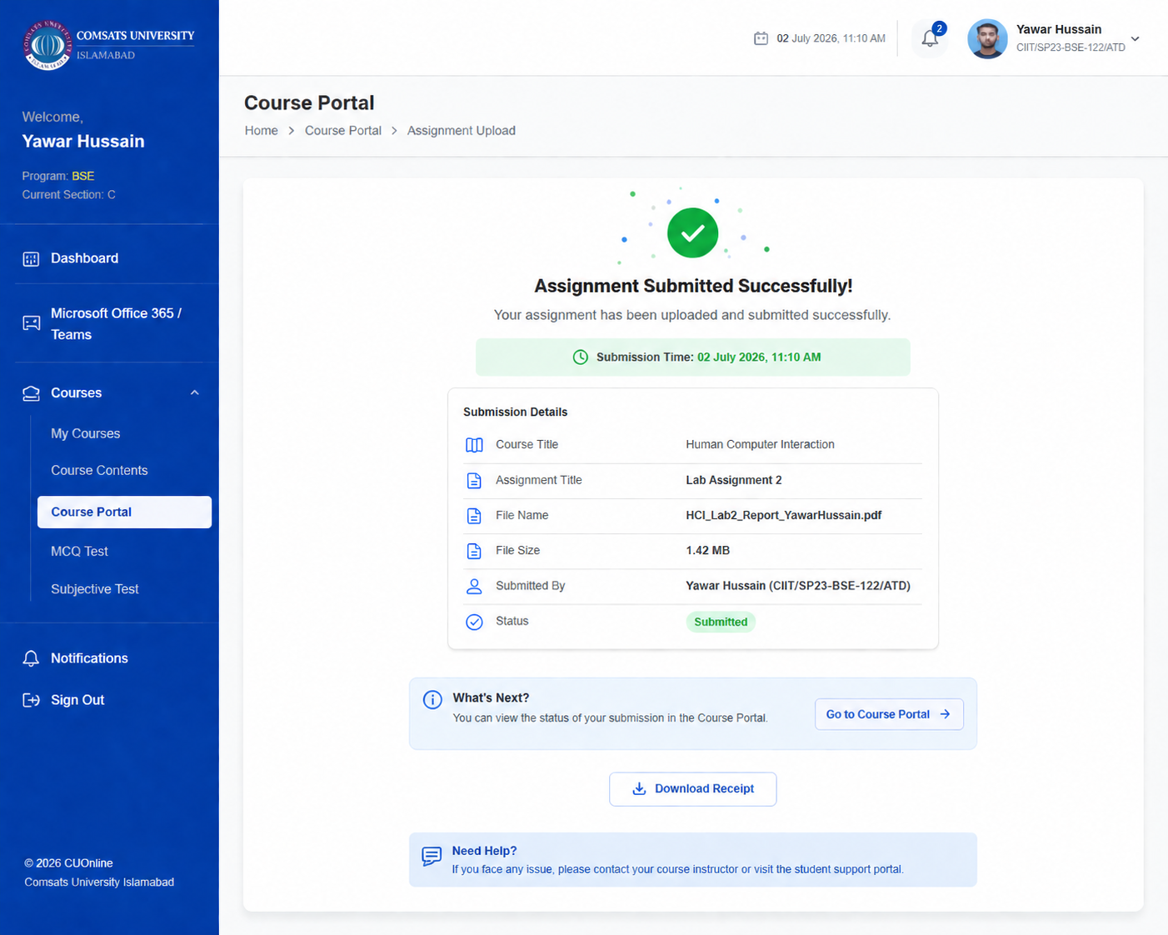

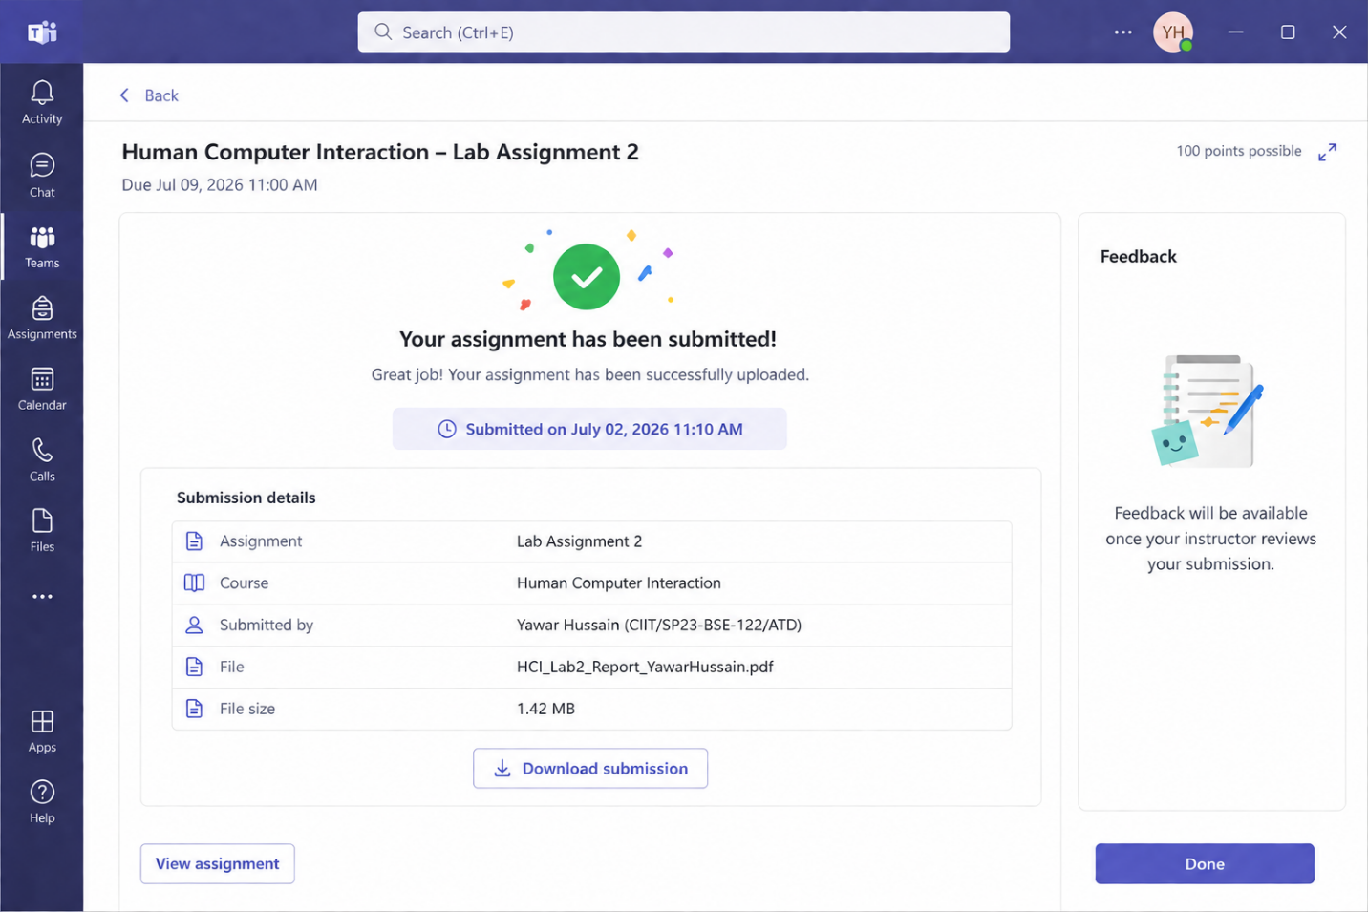

5. Data Collected (Class

Sample, n = 15 per platform)
The table below shows an illustrative dataset of upload times (in seconds) collected across the class, formatted the same way as the solved Kindle/iPad example. Replace these values with the actual times your class records.
Subject | CUOnline Time (s) | Teams Time (s)
1 | 45 | 38
2 | 50 | 40
3 | 48 | 37
4 | 52 | 39
5 | 47 | 41
6 | 49 | 36
7 | 53 | 38
8 | 46 | 42
9 | 51 | 37
10 | 44 | 39
11 | 50 | 40
12 | 48 | 38
13 | 47 | 41
14 | 52 | 37
15 | 49 | 39

6. Applying the ttest
Statistic | CUOnline | Teams
Mean | 48.73 | 38.80
Standard Deviation | 2.66 | 1.74
Variance | 7.07 | 3.03
Count (n) | 15 | 15

Using the tvalue formula:
|x̄1 x̄2| | 9.933
s1²/n1 + s2²/n2 | 0.4711 + 0.2019 = 0.6730
√(s1²/n1 + s2²/n2) | 0.8204
tvalue | 12.11
df = n1 + n2 2 | 28
Critical value (onetail, p = 0.05, df = 28) | 1.701

7. Conclusion
The calculated tvalue (12.11) is far greater than the onetailed critical value for df = 28 at p = 0.05 (1.701). Therefore, we reject the null hypothesis and accept the research hypothesis: Microsoft Teams produced a significantly faster average upload time (̄x = 38.80 s) than CUOnline (̄x = 48.73 s) for this sample of students, with the difference being unlikely to be due to chance.
Note: The exact numbers above are illustrative, mirroring the format of the solved Kindle vs. iPad example. Once your class finishes collecting real timing data, replace the values in Section 5, recompute the statistics in Section 6 (Excel's AVERAGE, STDEV.S, and VAR.S functions work well here, as suggested in the lab handout), and update the conclusion in Section 7 accordingly.

